

ECONOMICS STAGE 3 SAMPLE EXAMINATION

Section 7 of the New WACE Manual: General Information 2006–2009 outlines the policy on WACE examinations.

Further information about the WACE Examinations policy can be accessed from the Curriculum Council website at http://newwace.curriculum.wa.edu.au/pages/about_wace_manual.asp.

The purpose for providing a sample examination is to provide teachers with an example of how the course will be examined. Further finetuning will be made to this sample in 2007 by the examination panel following consultation with teachers, measurement specialists and advice from the Assessment, Review and Moderation (ARM) panel.

0000.doc




Western Australian Certificate of Education, Sample External Examination
Question/Answer Booklet

ECONOMICS
Please place your student identification label in this box
WRITTEN PAPER
STAGE 3

Student Number: In figures

In words

Time allowed for this paper
Reading time before commencing work: Ten minutes
Working time for paper: Three hours

Material required/recommended for this paper
To be provided by the supervisor
This Question/Answer Booklet’
Multiple Choice Answer Sheet

To be provided by the candidate
Standard Items: Pens, pencils, eraser or correction fluid, highlighter and ruler.
Special Items: Calculators satisfying the conditions set by the Curriculum Council for this subject.

Important note to candidates
No other items may be taken into the examination room. It is your responsibility to ensure that you do not have any unauthorised notes or other items of a non-personal nature in the examination room. If you have any unauthorised material with you, hand it to the supervisor before reading any further.

Structure of this paper

Section | Suggested working time | Number of questions available | Number of questions to be attempted | Marks available
Section One  Multiple Choice | 30 minutes | 24 | All | 24
Section Two:  Data interpretation/short answer | 70 minutes | 3 | All | 36
Section Three:  Extended writing | 80 minutes | 4 | 2 | 40
 |  |  | [Total marks] | 100

Instructions to candidates

- The rules for the conduct of Curriculum Council WACE examinations are detailed in the Student Information Handbook. Sitting this examination implies that you agree to abide by these rules.

- Answer all questions in the Question/Answer Booklet in blue or black ballpoint or ink pen. Wherever appropriate, fully labelled diagrams and examples should be used to illustrate and support your answers.

- You must be careful to confine your responses to the specific questions asked and to follow any instructions that are specific to a particular question.

SECTION ONE—MULTIPLE-CHOICE

Attempt ALL questions from this section.

For questions 1-24 choose the alternative which most correctly answers the question or completes the statement. Record your answers on the separate multiple-choice answer sheet using a 2B, B or HB pencil. Read the instructions on this sheet with care. Each question is worth one mark.

Allow approximately 30 minutes for this section. [24 marks]

- When expressed as a percentage of Gross Domestic Product, which of the following is a measure of external stability?
[1 mark]
- capital inflow
- the budget deficit
- household savings ratio
- the current account deficit

- Use the table below showing economic data for a hypothetical country to answer this question.

Selected economic data for a nation
BALANCE OF PAYMENTS | $m
Current Account  Goods credit  Goods debit  Net Services  Net Income | 300  450  -360  ?
Capital and Financial Account balance | +1300

What is the value of Net Income?
[1 mark]
- –$790 m
- –$510 m
- $190 m
- $910 m
- When foreign tourists pay for hotel accommodation in Sydney, how is this recorded in Australia’s balance of payments?
[1 mark]
  - as a debit on the Australian capital and financial account
  - as a credit on the Australian capital and financial account
  - as a debit on the Australian current account
  - as a credit on the Australian current account

- See the diagram below which illustrates the effect of a tariff to answer this question.

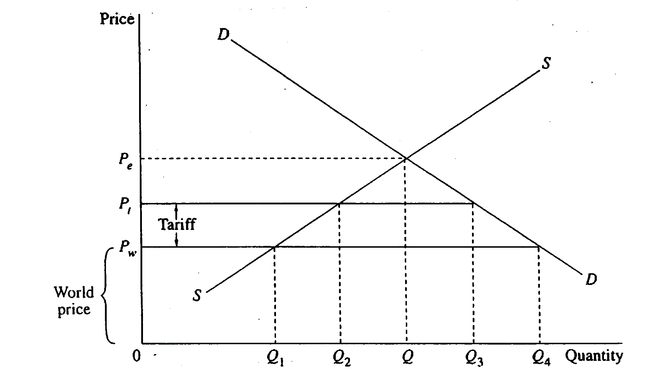

Which of the following represents the effect of this tariff on the economy?
[1 mark]
- The domestic price would increase to the equilibrium price (0P_{e}^{).}
- Domestic production would increase from 0Q₁ to 0Q₂.
- Import volumes would increase from 0Q₂ to 0Q₃.
- Government revenue would be equal to the world price (0P_{w})

- How does the impact of a tariff differ from that of an import quota?
[1 mark]
- A tariff disadvantages consumers, while a quota does not.
- A tariff generates tax revenue to the government, while a quota does not.
- A tariff encourages increased domestic production, while a quota does not.
- A tariff advantages domestic producers, while a quota does not.

- Use the diagram below to answer this question, which assumes a floating exchange rate.
[1 mark]
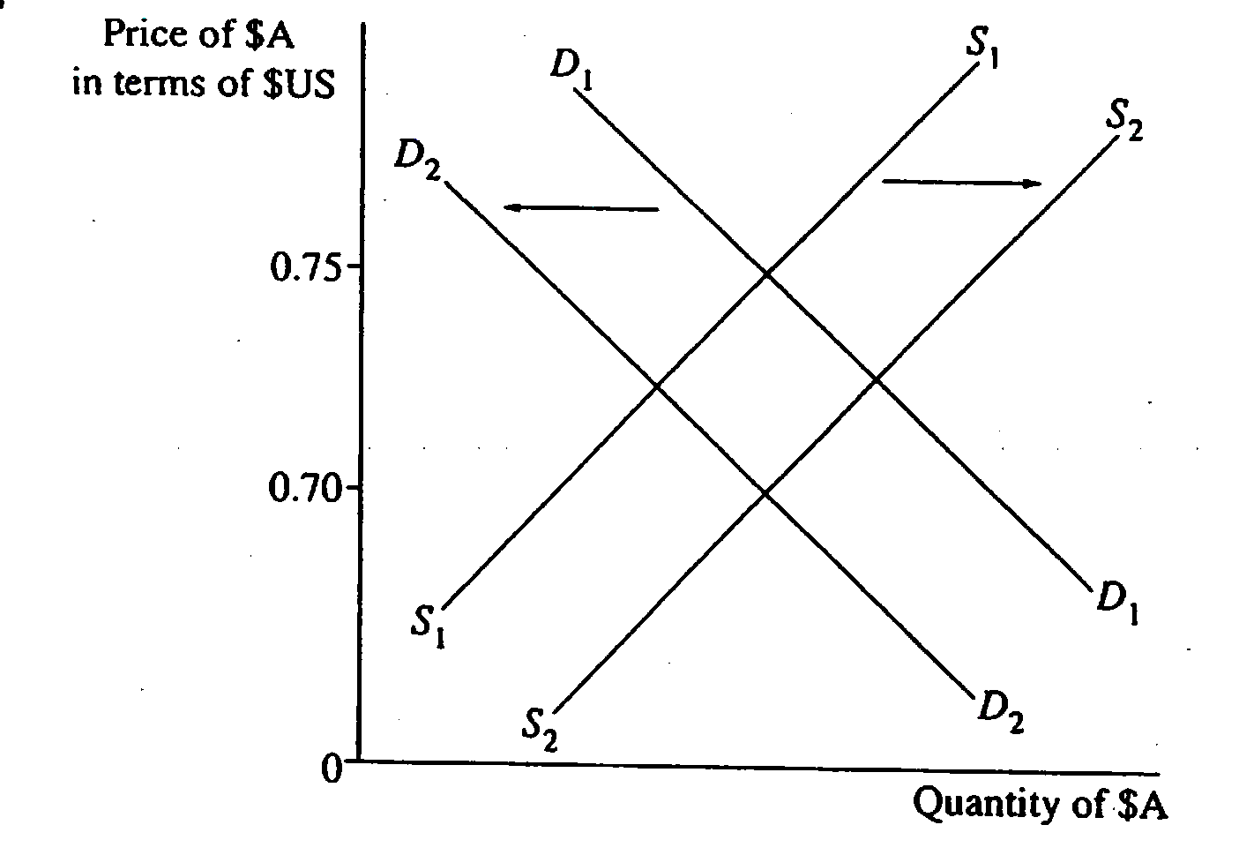
Which of the following actions by the Reserve Bank of Australia have caused the exchange rate to move from $US0.75 to $US0.70?
[1 mark]
- buying Australian dollars and raising Australian interest rates.
- buying Australian dollars and lowering Australian interest rates.
- buying United States dollars and lowering Australian interest rates.
- selling United States dollars and raising Australian interest rates.

- A reason why a multinational corporation would locate their production in developing countries is that
[1 mark]
- there is an abundance of highly skilled labour available
- there is an abundance of unskilled labour available and labour costs are low
- wages are low and the workforce is highly skilled
- capital is cheaper and production methods are more capital intensive.

- What is an advantage of free trade?

- Nations are free to take measures to protect all domestic industries.
- Nations attempt to become self-sufficient to satisfy domestic wants.
- Nations are able to specialise and as a result produce more output.
- Nations can prevent cheap imports being dumped on domestic markets.

- Use the table below showing international investment transactions for a hypothetical economy, to answer this question.

Year | Equity investment abroad  ($ billion) | Foreign liabilities  ($ billion)
1 | 90 | 150
2 | 250 | 300

From Year 1 to Year 2, which statement is correct for this economy?
[1 mark]
- The economy’s net foreign debt is increasing.
- Equity investment as a proportion of foreign liabilities is increasing.
- Foreign liabilities are increasing at a greater rate than equity investment.
- The increase in equity investment will worsen the economy’s foreign debt.

- Which international organisation is mainly responsible for monitoring and enforcing global multilateral trade agreements?
[1 mark]
- Association of South East Asian Nations
- Asia Pacific Economic Cooperation
- World Trade Organisation
- International Monetary Fund

- An appreciation in the Australian dollar against the world’s major currencies will most likely
[1 mark]
- assist Australian exporters to sell their products in overseas markets
- cause the Reserve Bank of Australia to raise interest rates
- lead to job losses in the Australian tourism industry
- produce an increase in Australia’s rate of inflation.

- Under a floating exchange rate system, what would be the likely effect of a fall in Australia’s inflation rate relative to the average rate of inflation of Australia’s major trading partners?
[1 mark]
- a rise in Australia’s interest rates.
- a decrease in the supply of foreign currency.
- a deterioration in the balance on current account.
- an increase in the demand for the Australian dollar.

- The use of fiscal policy to promote full employment and low inflation describes the
[1 mark]
- stabilisation function of government
- redistribution function of government
- reallocation function of government
- political function of government.

- The federal government performs its redistribution function mainly through
[1 mark]
- trade practice legislation against anti-competitive behaviour
- the provision of public goods
- taxes and transfer payments
- tariffs on imports.

- A contractionary monetary policy will
[1 mark]
- increase interest rates, shifting aggregate demand to the right
- increase interest rates, shifting aggregate demand to the left
- decrease interest rates, shifting aggregate demand to the right
- decrease interest rates, shifting aggregate demand to the left.

- An increase in labour productivity is most likely to be caused by
[1 mark]
- an increase in portfolio investment from overseas
- a fall in the natural rate of unemployment
- the process of capital widening
- increased capital deepening.

- Monetary policy settings are adjusted more frequently than fiscal policy because
[1 mark]
- monetary policy is much more direct and can target specific areas of the economy
- monetary policy has a short implementation lag but a long effect lag
- monetary policy can only be changed with the agreement of the government and the Reserve Bank
- fiscal policy is used mainly to attempt to buy votes.

- The Australian income tax system is as follows:

Taxable Income  $ | Marginal Rate of Tax (%) from 1 July 2007 | Taxable Income  $ | Marginal Rate of Tax (%) from 1 July 2008
0-6,000 | 0 | 0-6,000 | 0
6,001-30,000 | 15 | 6,001-30,000 | 15
30,001-75,000 | 30 | 30,001-80,000 | 30
75,001-150,000 | 40 | 80,001-180,000 | 40
150,001+ | 45 | 180,000+ | 45

This income tax system is described as
[1 mark]
- regressive
- progressive
- proportional
- flexible.

- Which of the following would not be considered an aim of microeconomic reform?
[1 mark]
- to achieve sustainable economic growth
- to raise the productive capacity of the economy
- to improve the efficiency of resource allocation
- to reduce income inequality

- A downturn in world economic growth is likely to cause
[1 mark]
- a decrease in the size of Australia’s budget surplus and a tightening of monetary policy in Australia
- an increase in the size of Australia’s budget surplus and a tightening of monetary policy in Australia
- a decrease in the size of Australia’s budget surplus and a loosening of monetary policy in Australia
- an increase in the size of Australia’s budget surplus and a loosening of monetary policy in Australia.
- Monetary policy is of limited use to a government when it is trying to stimulate the economy because
[1 mark]
- low interest rates are a disincentive to investors
- expectations are a more important determinants of business behaviour than interest rates
- long implementation lags cause timing problems which make interest rate changes counter–productive
- the board of the Reserve Bank is concerned only with price stability and does not see economic stimulation as one of its roles.

- Which one of the following is an example of an automatic stabiliser?
[1 mark]
- the full privatisation of Telstra
- a reduction in marginal income tax rates
- an increase in interest rates due to higher inflation levels
- an increase in company tax collections due to stronger economic growth

- Which of the following policy combinations is most likely to cause an increase in aggregate demand?
[1 mark]
- an increase in interest rates and an increase in government spending
- an increase in interest rates and a decrease in government spending
- a decrease in interest rates and a decrease in government spending
- a decrease in interest rates and an increase in government spending

- One reason the budget surplus could be smaller than that originally estimated by the Australian government could be
[1 mark]
- an unexpectedly good wheat harvest
- a rise in the price of gold leading to increased export receipts
- an unexpected rise in the inflation rate causing the Australian Dollar to devalue against the US Dollar
- an unexpected rise in the unemployment rate coupled with a fall in the participation rate.

END OF SECTION ONE
SECTION TWO—DATA INTERPRETATION AND SHORT ANSWER

Attempt ALL questions from this section. Each question is worth 12 marks.

Write your answers in the spaces provided under each part of each question. The space
provided indicates the required length of the answer.

Allow approximately 70 minutes for this section [36 marks].

Question 1
This question refers to the graph below.

For copyright reasons this graph cannot be reproduced in the online version of this document.

- Briefly explain the meaning of the concept of the terms of trade.
[2 marks]

- Outline the reasons for the trend in Australia’s terms of trade over the last five years as illustrated in the graph.
[4 marks]

- Explain the effects that the changes in the terms of trade over the last five years, as shown in the graph, could have had on the Australian economy.
[6 marks]

Question 2
[From: Board of Studies NSW, 2006]
The table below shows selected data for a hypothetical economy that uses a floating exchange rate system.

Balance of payments items | $ billion
Exports | 110
Imports | 130
Net services | 15
Net incomes | -25
Capital account | 4
Financial account | 26

- Calculate

(i) the balance on goods and services __________
(ii) the balance on the current account __________ .
[2 marks]

- Briefly explain the relationship between the current account and the capital and financial account under a floating exchange rate system.
[4 marks]

- Explain the impact of a rise in domestic interest rates in this economy on the components of its balance of payments.
[6 marks]

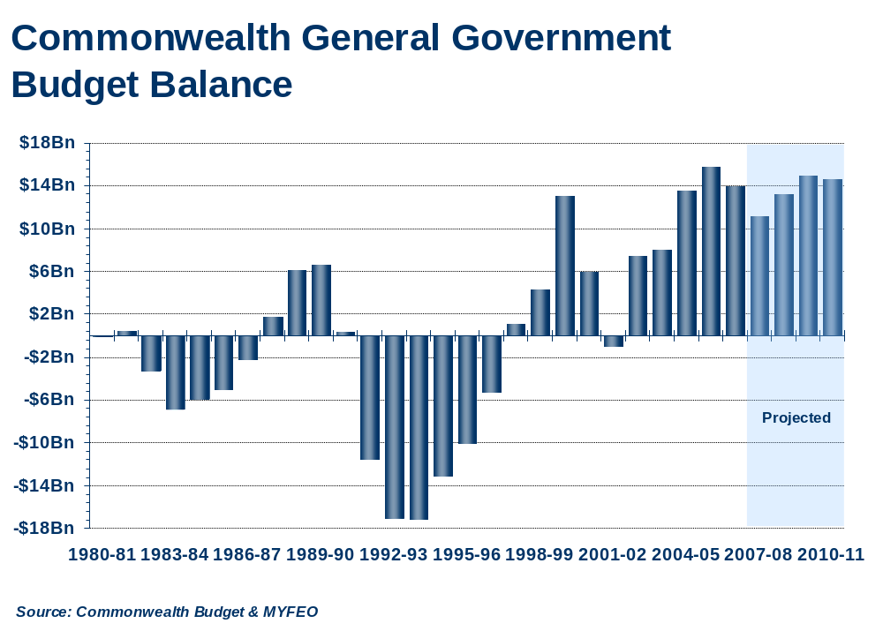
Question 3

For copyright reasons this graph cannot be reproduced in the online version
of this document.
2002-03

- (i) What amount is the expected budget surplus for 2002–03?
[1 mark]

(ii) Over the three year period following 2002–03 (i.e. 2003–04 to 2005–06) is the fiscal policy stance contractionary, expansionary or neutral?
[1 mark]

- Explain how the trends in the budget outcomes since 1990 reflect fluctuations in the business (trade) cycle over this period.
[4 marks]

- Using an appropriate economic model, explain and illustrate how changes in budget outcomes can impact on the level of economic activity.
[6 marks]

END OF SECTION TWO

SECTION THREE—EXTENDED WRITING

Attempt TWO (2) questions from this section.

Answer the question in the Question/Answer Booklet.

Allow about 80 minutes for this section [40 marks].

In this section your answers will be assessed on how well you:
- use your knowledge of economic theory and where applicable, the information provided
- apply economic terms, concepts, relationships and theory
- present a sustained, logical and well-structured answer to the question.

Question 4
Read the following articles which refer to some effects of foreign investment and reduced protection.

The International Monetary Fund (IMF) has estimated that world income would increase by at least US$250bn if agricultural protection were abolished, with both rich and poor countries benefiting from increased trade. (Department of Foreign Affairs and Trade, 2003)

Some groups in developing and developed countries, however, are opposed to reduced levels of protection, for example, food importers fear higher prices if agricultural export subsidies are removed.
[From: Board of Studies NSW, 2006]

For copyright reasons this text cannot be reproduced in the online version of this document. | Let's welcome foreign investment  Forget private equity for a minute: China—along with other energy–rich nations Saudi Arabia, Norway, Russia—is awash with cash. And these nations may soon set new investment benchmarks that make no company too large to acquire.  The shift that is occurring is merely the latest effect of globalisation, the international tides and currents of investment and trade as national barriers come down.  After World War II Japan went through this process: received foreign investment, developed manufacturing industry and then invested its earnings abroad, with mixed results during the 1980s.  Foreign investment inflows into China in recent decades have lifted that country's export performance to such an extent that it is running massive trade surpluses. The Chinese build; the West buys.  [Adapted from: Australian Financial Review, 12 June 2007]
With reference to the articles, where appropriate, evaluate the potential impact on the Australian economy of reduced barriers to the free movement of goods and services and investment funds.
[20 marks]
Question 5
In July 2007 the Australian dollar reached its highest value against the US dollar for 18 years. It had also been appreciating against most other world currencies.

Outline the possible causes of this increase in demand for the Australian dollar and discuss the impacts on the Australian economy of a sustained appreciation of the dollar.
[20 marks]

Question 6
High rates of consumer spending supported by rising household wealth, together with a solid rise in business investment has led to strong economic growth in the Australian economy in recent times.

- Outline the main determinants that could have contributed to the rise investment spending.
[5 marks]

- Using a diagram, explain how changes in the value of the marginal propensity to consume would affect the level of economic activity.
[5 marks]

- In July 2007 a proposed $11 billion liquid natural gas project in Western Australia’s North-West was given the go ahead. It was claimed that the project would contribute billions of dollars to the state’s economy and that it would generate thousands of jobs.

Using the Keynesian cross/aggregate expenditure model, explain how this injection of business investment spending impacts on the equilibrium level of output and income in the economy.
[10 marks]

Question 7
The table below shows selected economic data for the Australian economy.

Key economic indicators | 2004 | 2005 | 2006 | 2007
Real GDP growth rate (%)  For copyright reasons this information cannot be reproduced in the online version of this document. | 3.0 | 2.6 | 2.9 | 3.3
Consumer price index (inflation) % | 2.3 | 2.7 | 3.2 | 2.9
Unemployment rate | 5.6 | 5.1 | 4.7 | 4.3
Household saving rate (% GDP) | -3.0 | -2.2 | -0.7 | -1.5
Budget balance (% GDP) | 1.0 | 1.0 | 1.4 | 1.5
Current account balance (% GDP) | -6.4 | -5.8 | -5.6 | -5.7
Foreign debt (% GDP) | 51.1 | 48.3 | 51.8 | 52.0
RBA cash rate (%) | 5.25 | 5.25 | 5.5 | 6.5
[Adapted from: OECD, 2006]

Making reference to data from the table examine how effectively the government has used monetary policy, fiscal policy and microeconomic reform to achieve its economic objectives of price stability, full employment and sustainable economic growth.

THIS PAGE HAS BEEN LEFT BLANK INTENTIONALLY

YOU MAY USE IT FOR PLANNING
ACKNOWLEDGEMENTS

SECTION TWO

Question 1: Graph from: Reserve Bank of Australia. (2006, February). [Terms of trade and trade prices]. In Gittins, R., et al. (2006).The Australian economy: A student’s guide to current economic conditions. Fitzroy, Vic.: Warringal Publications, p. 18.

Question 2: Adapted from: Board of Studies NSW. (2006). Economics: 2006 Higher School Certificate Examination (pp. 17–18). Retrieved August, 2006, from http://www.boardofstudies.nsw.edu.au/hsc_exams/hsc2006exams/pdf_doc/economics_06.pdf.

Question 3: Graph adapted by Chamber of Commerce and Industry of Western Australia from: Australian Government. (n.d.). [Budget and mid-year economic and fiscal outlook].

SECTION THREE

Question 4: Article 1
Department of Foreign Affairs and Trade. (2003). Advancing the national interest: Australia’s foreign and trade policy white paper (p. xiii). Retrieved September, 2007, from http://www.dfat.gov.au/ani/dfat_white_paper.pdf.

Board of Studies NSW. (2006). Economics: 2006 Higher School Certificate Examination (p. 19). Retrieved August, 2006, from http://www.boardofstudies.nsw.edu.au/hsc_exams/hsc2006exams/pdf_doc/economics_06.pdf.

Article 2
Adapted from: Let’s welcome foreign interest. (2007, June 12). The Australian Financial Review, p.70.

Question 7: Graph adapted from: OECD. (2006). Economic outlook 2005–2006. In Board of Studies NSW. (2006). Economics: 2006 Higher School Certificate Examination (p. 20). Retrieved August, 2006, from http://www.boardofstudies.nsw.edu.au/hsc_exams/hsc2006exams/pdf_doc/economics_06.pdf.
Published by the Curriculum Council of Western Australia
27 Walters Drive
OSBORNE PARK WA 6017

